Please submit this form if you will be working as a TA/RA during
【Form 2-4】
the spring semester starting April 1st or during the fall semester
starting October 1st.

TA・RA Estimated Annual Income Certificate
April
October

As of 1, 2026

Student ID Number: Name:

1. Information of the worker.
Name | （Relationship ）

2. Please calculate the estimated annual income based on the working schedule after October 1
for fall semester applications.
Teaching Assistants (TAs) work schedule
Please select and complete either (1) or (2) below.
(1) Filled in from the Teaching Assistant Acceptance Form. |  |  | (2) Fill in from your supervisor's e-mail.  Note: Submit a printed copy of the email from your supervisor with the following information.
Hourly wage | yen | ① | Hourly wage | yen | ①
Acceptance Period  *MM/YYYY | From / |  | Times per class | hour | ②
Acceptance Period  *MM/YYYY | till / |  | Number of classes | times | ③
Acceptance Period  *MM/YYYY | Month(s) | ②
Working hours | hour(s)/month | ③
Estimated income（①×②×③） |  |  | yen

Research Assistants (RAs) work schedule
Please select and complete either (1) or (2) below.
(1) Fill in from the Research Assistant Acceptance Form. |  |  | (2) Fill in from your supervisor's e-mail.  Note: Submit a printed copy of the email from your supervisor with the following information.
Hourly wage | yen | ① | Hourly wage | yen | ①
Acceptance Period  *MM/YYYY | From / |  | Acceptance Period  *MM/YYYY | From /
Acceptance Period  *MM/YYYY | till / |  | Acceptance Period  *MM/YYYY | till /
Acceptance Period  *MM/YYYY | Month (s) |  | Acceptance Period  *MM/YYYY | Month (s) | ②
Hours of work  (During the period of acceptance) | hours | ③ | Monthly Engagement Hours | hours | ③
Estimated income（①×③） | yen |  | Estimated income（①×②×③） | yen
Required Attached documents:
Teaching Assistant Acceptance Form or Research Assistant Acceptance Form
If you cannot submit the Acceptance Form, please submit a printout of the e-mail from the supervisor.

Example of documents to be submitted

Teaching Assistant Acceptance Form Research Assistant Acceptance Form
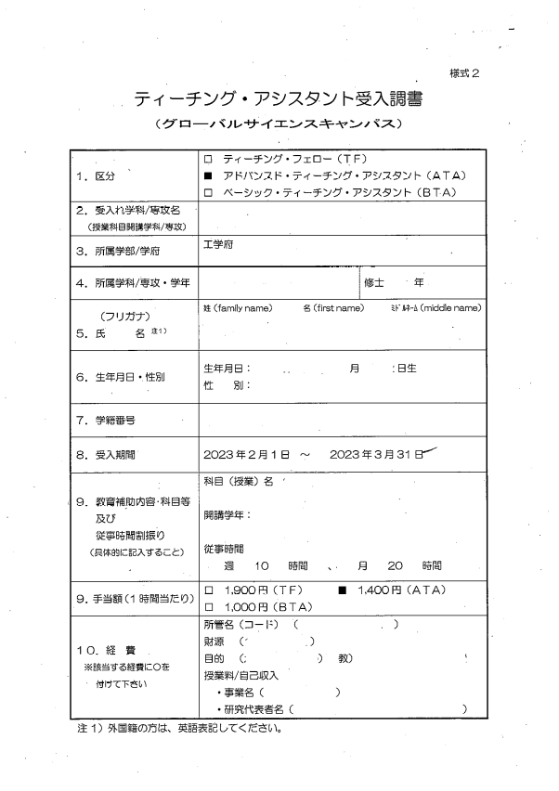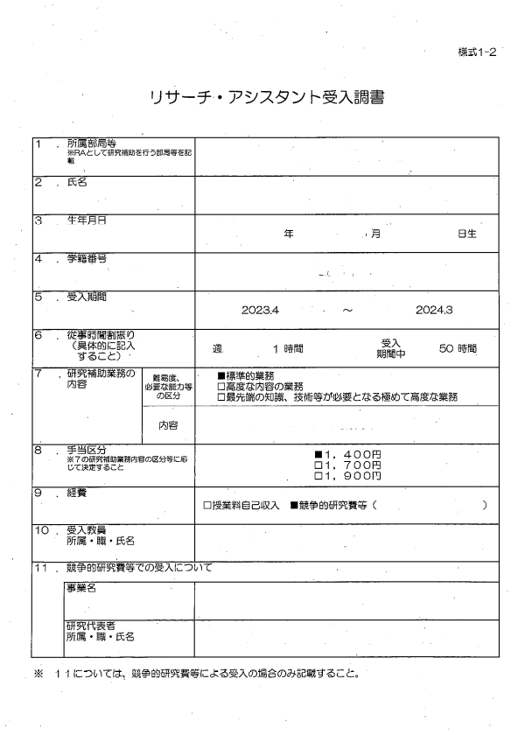

Example of e-mail from supervisor

In the case of TA (Teaching Assistant)
(1) Hourly wage: 1,400 yen
(2) Time per class: 1.5 hours
(3) Number of classes in charge: 8

In the case of RA (Research Assistant)
(1) Hourly wage: 1,400 yen
(2) Acceptance period: April 2026 to September 2026
(3) Hours worked per month: 20 hours

