【Form3- 1】
Please attach the withholding tax slip（A4 size）to the back and staple it together.
April
October
As of 1, 2026

Attachment Sheet for the Withholding Slip

Student ID Number: Name:
Name of salary earner | (Relationship: )
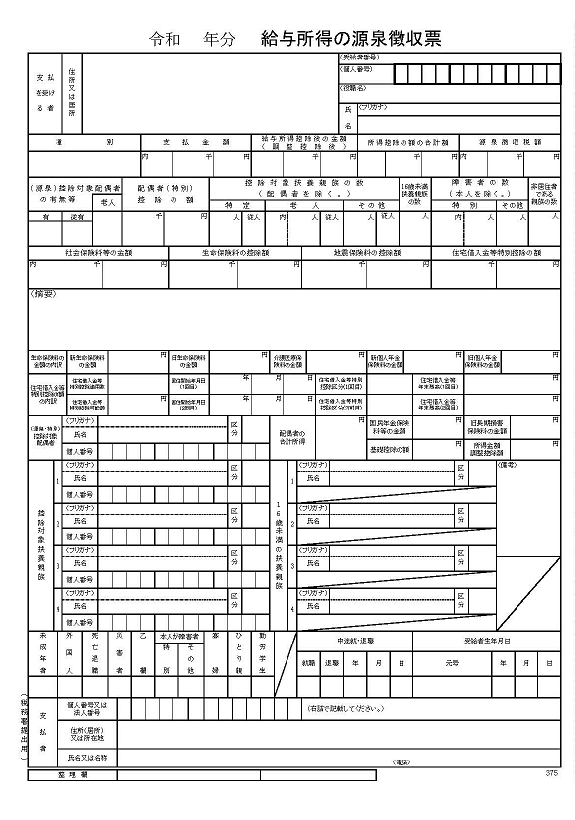
Where to check
Please submit a copy for 2025.
* In the case of the previous application, it does not match the year and amount of the tax certificate, but there is no problem.

Please enter the payment amount in the salary income column only if you do not fall under (A), (B), or (C) below.

- column for dependents
* Only the fiscal year is listed.
It does not apply to mid-career employment or retirement.

- Mid-career employment/retirement

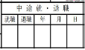

7

Please check the following items and ☑fill in the required information if applicable.
Where to check | Things to check | ☐ | Withholding tax  slip | What you'll need
(1) Dependents column | There is a sibling whose name is written on the withholding tax slip but no longer a dependent on the application record date. | ☐ | Applicable Person's Name:  Reason (e.g., employment, etc.):
(2) Mid-career employment  retirement | - There is a description of mid-career employment. | ☐ | 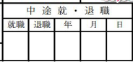  〇 7 10 1 | Date of Employment: YYYY/MM/DD  / /  * Submit Form 2-1
(2) Mid-career employment  retirement | - There is a description of retirement. | ☐ | 〇 7 9 30 | Retirement date: YY/MM/DD  / /  After retirement  ⇒Unemployed, Changing jobs,  Others ( )  * Submit Form4, Form 2-1
(2) Mid-career employment  retirement | - Not listed but re-employed  Was | ☐ |  | Date of reemployment: YYYY/MM/DD  / /  * If your annual income changes, submit Form 2-1.
(2) Mid-career employment  retirement | - Although it is listed, the annual income stated on the withholding tax certificate does not change. | ☐ | maru  〇 7 4 1 | Reason  (e.g., for annual renewal, etc.):  * Not possible if there is a description of the previous job in the summary column.  Please submit Form 2-1.
(3) Compared to the salary income column of the income (taxation) certificate, the income has decreased by more than 1,000,000 yen. ☐
Example: Due to re-employment from 0/00, decrease in revenue due to deterioration in business performance, job change, W work, etc.
Reason:

(4) Not applicable None of (1), (2), and (3) above applies.☐
* If it is not checked correctly and falls under (1) and (2), we will correct it here.

